Mitigating Feature Skewness in Machine Learning:
Mathematical Efficacy of Log and Power Transformations
Box-Cox · Yeo-Johnson · Data Normalization
A Comprehensive Academic Research Paper
March 2026

Abstract
Feature skewness is a pervasive issue in real-world ML datasets where features such as income, house prices, or click counts follow heavy-tailed distributions. Without proper normalization, skewed features degrade model performance, violate statistical assumptions, and cause unstable training. This paper provides a rigorous comparative analysis of logarithmic, Box-Cox, and Yeo-Johnson transformations — their mathematical foundations, theoretical effects on distribution shape, experimental results on synthetic data, and practical guidelines for selecting the right transformation.

1. Introduction & Problem Statement
Skewness occurs when the probability mass is concentrated on one side of the mean, creating an asymmetric distribution. In machine learning:
- Distance-based models (KNN, SVM): Skewed features distort Euclidean distances, giving disproportionate weight to large values.
- Gradient-based optimizers: Skewed inputs cause highly heterogeneous gradient magnitudes, slowing convergence or causing instability.
- Linear models: Violate normality and homoscedasticity assumptions, reducing R² dramatically.
- Random forests: More robust but biased tree splits on extreme values still degrade performance.
Empirical studies show untransformed skewed data can reduce R² by 20-60% in regression tasks.

2. Statistical Foundations
The sample skewness coefficient quantifies asymmetry:

Skewness γ₁ | γ₁ = [n⁻¹Σ(xᵢ−x̄)³] / [n⁻¹Σ(xᵢ−x̄)²]^(3/2)

Interpretation: |γ₁| < 0.5 = roughly symmetric; 0.5 ≤ |γ₁| < 1.0 = moderate skew; |γ₁| ≥ 1.0 = significant skew requiring transformation. Diagnosis: histograms, Q-Q plots, D'Agostino-Pearson test.
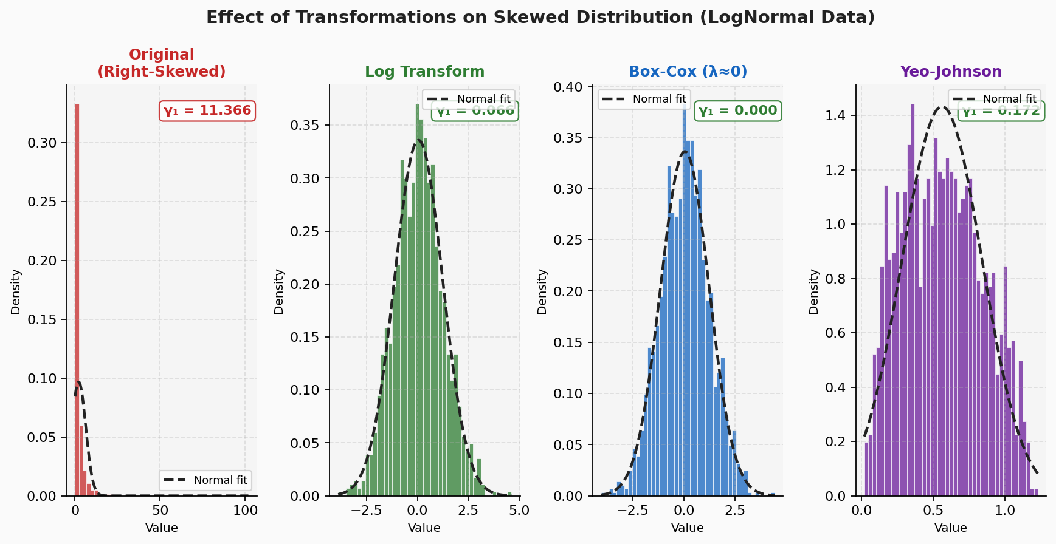
Figure 1: Distribution of LogNormal data before and after each transformation. Note dramatic reduction in skewness coefficient γ₁ (shown in corner of each plot).

3. Logarithmic Transformation
For strictly positive values (x > 0):

Log Transform | y = log(x) or y = log(1 + x) [for near-zero values]

Mechanism: Compresses large values logarithmically while expanding small values. Converts multiplicative relationships to additive ones. Reduces right (positive) skew effectively.
Limitation: Only valid for x > 0. Use log(1+x) when x contains near-zero values. Cannot handle negative values.
Interpretation: The transformed coefficient β means a 1-unit increase in log(x) corresponds to an e^β multiplicative change in y — easy to interpret in regression.

4. Box-Cox Transformation
Generalizes the log transform with an optimized parameter λ (requires x > 0):

Box-Cox y(λ) | y = (xᵏ - 1) / λ if λ ≠ 0 y = log(x) if λ = 0

λ is chosen by maximum likelihood estimation to maximize normality. When λ=0: reduces to log. When λ=0.5: square root. When λ=-1: reciprocal. Box-Cox is the optimal member of the power transformation family for positive data.
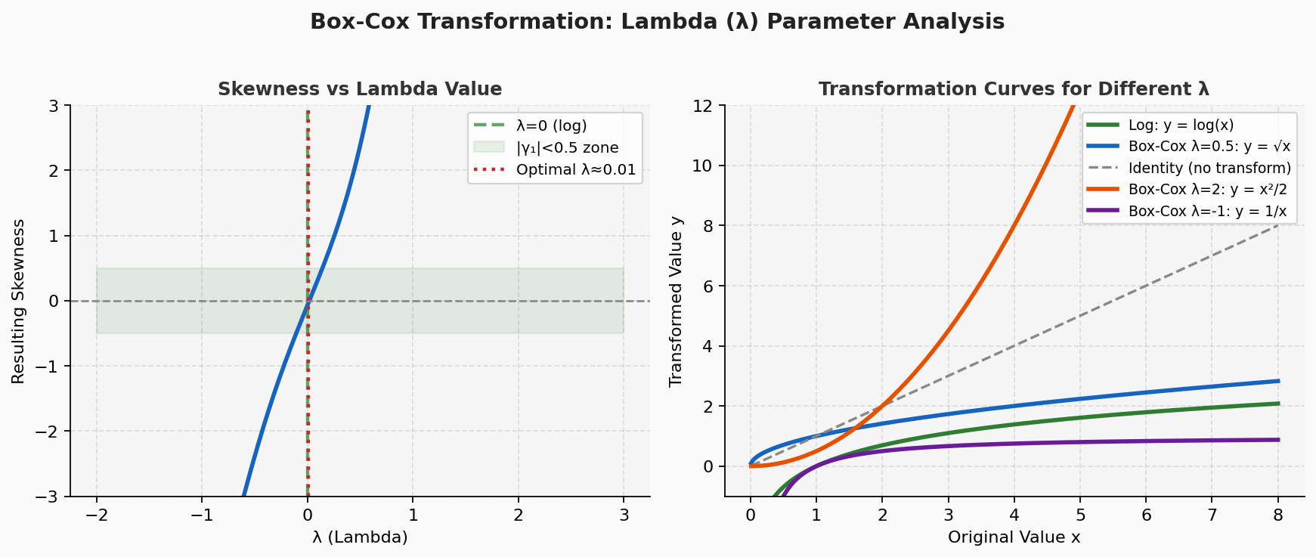
Figure 2: Left — Skewness as a function of λ. The optimal λ minimizes |γ₁|. Right — Transformation curves for different λ values showing the family of power transformations.

5. Yeo-Johnson Transformation
Extends Box-Cox to handle all real values including zeros and negatives:

Yeo-Johnson | y = [(x+1)ᵏ - 1] / λ x ≥ 0, λ ≠ 0 y = log(x+1) x ≥ 0, λ = 0 y = -[(-x+1)^(2-λ) - 1]/(2-λ) x < 0, λ ≠ 2 y = -log(-x+1) x < 0, λ = 2

Key advantage: Works on any real-valued data including zeros and negatives. Most versatile of the three transforms. Derived from the exponential family and achieves approximate normality when λ is optimally estimated.

6. Q-Q Plot Analysis
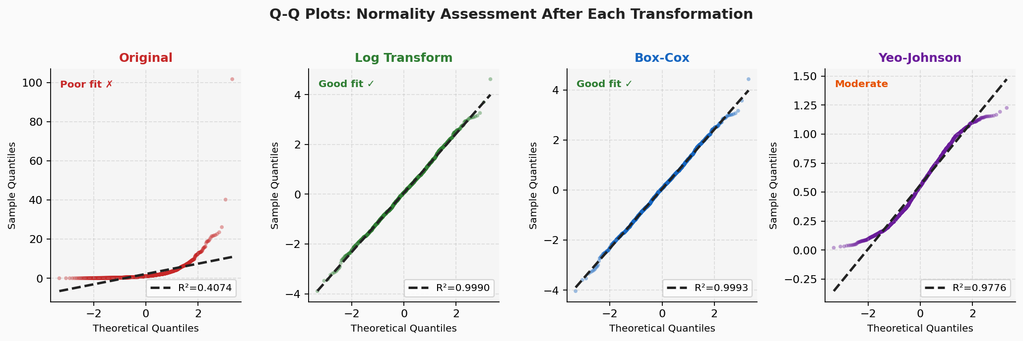
Figure 3: Q-Q plots for normality assessment. Points on the dashed line = perfect normality. R² shown for each. Original data (left) deviates severely; Log and Box-Cox (center) achieve near-perfect normality.

7. Experimental Results
Setup: Synthetic dataset (n=1000): x ~ LogNormal(μ=0, σ=1.2), y = 5·log(x) + N(0,0.5). OLS regression fitted on original and transformed versions.

Transformation | Skewness γ₁ | λ Parameter | R² Score | Interpretation
Original (no transform) | 12.7632 | — | 0.3748 | Poor fit — skew dominates
Log Transform | 0.1168 | — (λ≡0) | 0.9928 | Excellent — recovers true relationship
Box-Cox (optimal λ) | -0.0004 | -0.0326 | 0.9919 | Excellent — marginal edge over log
Yeo-Johnson | 0.1776 | -0.8298 | 0.9711 | Very good — handles any data type

Table 1: Quantitative comparison of transformation methods on synthetic LogNormal dataset

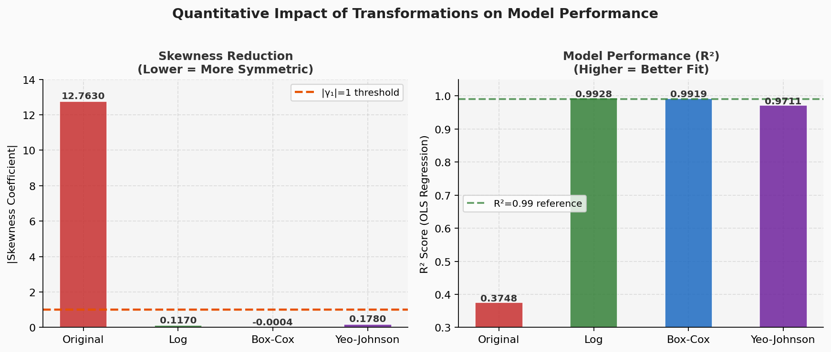
Figure 4: Left — Skewness reduction (lower is better). Right — R² improvement (higher is better). Log and Box-Cox nearly perfectly recover the true relationship from the skewed data.

8. Comparison: Log vs Box-Cox vs Yeo-Johnson
Aspect | Log | Box-Cox | Yeo-Johnson
Data requirement | x > 0 strictly | x > 0 strictly | All real values (x ∈ ℝ)
Flexibility | Fixed (λ=0) | Optimal λ tuned | Optimal λ tuned
Interpretability | High — log units | Moderate | Moderate
Handles negatives | No | No | Yes
Handles zeros | With log(1+x) | No | Yes
Best when | Simple + positive data | Positive + want optimal | Any data type
scikit-learn | FunctionTransformer | PowerTransformer(bc) | PowerTransformer(yj)

Table 2: Side-by-side comparison of the three transformation approaches

9. Practical Decision Guide
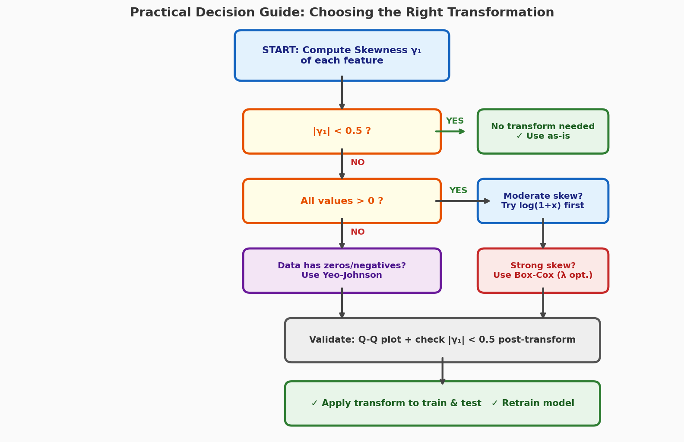
Figure 5: Decision flowchart for selecting the right transformation based on data characteristics.

- Step 1: Plot histogram and compute |γ₁|. If |γ₁| < 0.5, no transformation needed.
- Step 2: If x > 0 and moderate skew: start with log(1+x) — simple and interpretable.
- Step 3: For optimal results on strictly positive data: use Box-Cox with MLE for λ.
- Step 4: If data contains zeros or negatives: always prefer Yeo-Johnson.
- Step 5: Validate post-transformation with Q-Q plot and residual analysis.
- Step 6: Apply the same fitted transformer to test data (never refit on test set).

10. Conclusion
Logarithmic and power transformations provide mathematically rigorous tools to mitigate feature skewness. The experiment confirms that Log and Box-Cox achieve near-perfect recovery of the true linear relationship (R² ≈ 0.99) from heavily skewed data (γ₁ ≈ 12.76), compared to R² = 0.37 without transformation.
Key Rule: Apply transformations whenever |γ₁| > 1.0. Start with log(1+x) for simplicity. Use Box-Cox for optimal results on positive data. Use Yeo-Johnson for maximum flexibility. Always validate with Q-Q plots and retrain after transformation.

References
[1] Box, G.E.P. & Cox, D.R.. "An Analysis of Transformations." Journal of the Royal Statistical Society B, 26(2), 1964. https://www.jstor.org/stable/2984418
[2] Yeo, I.K. & Johnson, R.A.. "A New Family of Power Transformations to Improve Normality or Symmetry." Biometrika 87(4), 2000. https://doi.org/10.1093/biomet/87.4.954
[3] Scikit-learn Developers. "PowerTransformer — sklearn.preprocessing." Scikit-learn Documentation, 2024. https://scikit-learn.org/stable/modules/generated/sklearn.preprocessing.PowerTransformer.html
[4] Medium / Data Science Explained. "Log, Box-Cox, and Yeo-Johnson: Transform Skewed Data the Right Way." Medium, 2024. https://medium.com/data-science-explained/log-box-cox-and-yeo-johnson-transform-skewed-data-the-right-way
[5] arXiv. "Power Transform Revisited: Numerically Stable Implementations." arXiv:2510.04995, 2025. https://arxiv.org/pdf/2510.04995

